October 02, 2023

To Ms. Marianne S. Lara, LPT,

We humbly ask you to allow us, students (list of names written after this letter), to **enter** the school premises **without wearing the school’s prescribed uniform** on **October 02, 2023 (Monday)** and allow us to **work on our bulletin board.** Moreover, the students do promise to still adhere to the school’s dress code. Anyone who will not follow the said dress code shall be imposed with a sanction. Furthermore, it is to our understanding that the school may not be held responsible for any untoward incident that may happen beyond the school’s control.

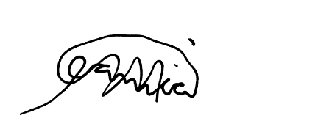

Respectfully yours,

**Danica Mae Balandra**

*2nd Year BSIT Student*

**Noted by:**

**MR. ERWIL AGBON**

*SSC Adviser*

**MS. ROMELYN BITAYO**

*OSA Head*

**Approved by:**

**MS. MARIANNE S. LARA, LPT**

*Prefect of Discipline*

**Name of Students:**

1. Reynaldo De Guzman
2. Nelben T. Acebo
3. Danica Mae Balandra
4. Ohara Michelle Nesley Elloren
5. Mary Stephanie Torrion
6. Deoruss Maglacion
7. Keith Jacka Degamon
8. Mykel Glenn Geronimo
9. Maribeth Caballes
10. Kyla Modio
11. Andrea Cecille B. Siodina
12. Noel Cayunda
13. Ken Perez
14. Jessalyn Legaspi
15. Gwyneth Franzyn Ledesma
16. Jean Laurente
17. Kristine Salvado
18. Joy Antecristo
19. Mae Ann Sator
20. Ronalyn Pencito
21. Maricris Abina
22. Christina Lumayag
23. Lara Jane Saragena
24. Sunshine Menosa
25. Francis Anne Erolon
26. Jomari Christian Constantino
27. Precious Justine Garay
28. Catherine Jean Cutamora
29. Joy Baladiang
30. Vanessa Angelou Cabardo
31. Raven Lerio
32. Edwin Baldimor
33. Shaila Jane M. Lubas